# Program 4: Currency App

## Overview

The app we made for project 4 was a currency converter as well as a currency calculator application. The purpose of this app is split into two:

Currency Converter: Converts amount from one currency to another currency.

Currency Calculator: Adds two sums of money together. Where if we have X USD + Y EUR, we will get Z EUR returned.

Our app can convert to and from EUR, USD, CAD, AUD, CNY, and JPY into any of the others, including itself! It can also add any of the types of currency together.

We used <https://fixer.io/> as our API for the program. It takes a type of currency (USD, CAD, etc..) and gives the exchange rate from Euro’s to that type of money. From there we use some fun math to convert the other number. Each button press is the same as one API-call.

Included we have our API key in there, so you don’t need to set up anything. However, for testing and such, we have had our API in an XML resource which was excluded from our Git Project (I read that this is proper form). We have around 1000 API calls until the end of the month. I think the app won’t work anymore once we run out, so please be kind to our API account!

## Screen Shots:

### Fragment 1:

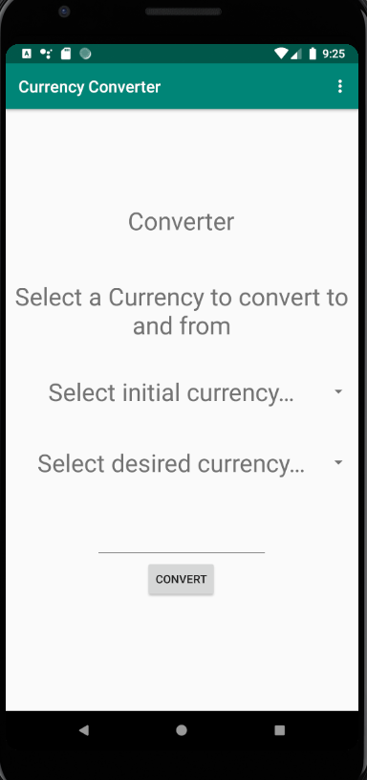

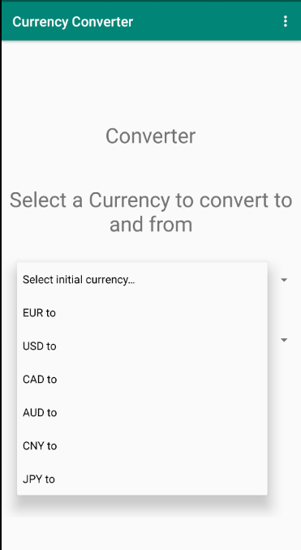

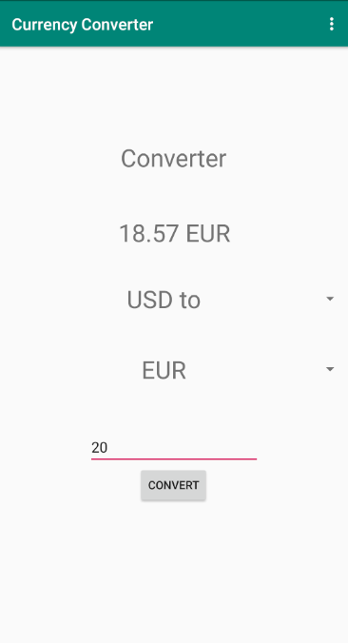

### Fragment 2:

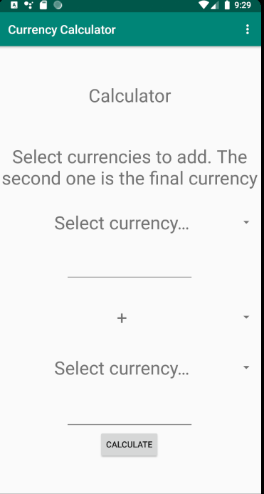

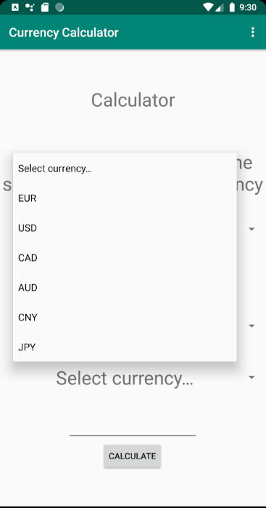

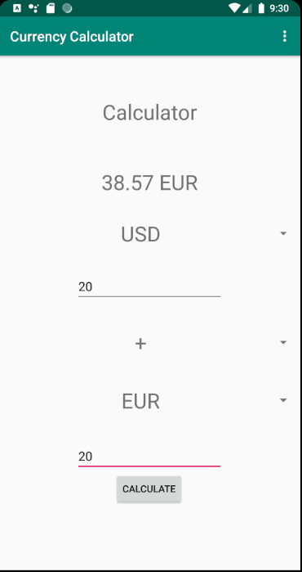

Menu:

